



**Kulliyyah OF Information & Communication Technology**

INFO3401–HUMANCOMPUTER INTERACTION

GROUP ASSIGNMENT 2

**Submitted To: Dr. Madihah S. Abd. Aziz**

**Submitted by:**

**MD. Afique Amin Zian. 1631005**

**Nasik Sami khan. 1638153**

**Md Arian Rahman. 1427517**

**Asif Mujtoba Newaz 1520071**

**Mohamed Lahmed Ahmedou 1711957**

**Date of Submission: 12/12/2018**

**Table Of Content:**

|  |  |  |
| --- | --- | --- |
| Sr no | Topic | Page |
| 1 | Introduction to UT | 3 |
| 2 | Discussions on the UT | 3-4 |
| 3 | Implications of your proposed design based on the first evaluation on sketches and High Fidelity Prototypes | 4-5 |
| 4 | Methodology | 5-6 |
| 5 | Findings | 6-10 |
| 6 | Conclusion | 10 |
| 7 | Complete high fidelity prototype screens | 11-14 |
| 8 | Attachments | 15-16 |
| 9 | References and Youtube Link | 17 |

**Introduction of the UT:**

A usability test is intended to determine the extent an interface facilitates a user’s ability to complete routine tasks. Typically the test is conducted with a group of potential users either in a usability lab, remotely (using e-meeting software and telephone connection), or on-site with portable equipment. Users are asked to complete a series of routine tasks. Sessions are recorded and analyzed to identify potential areas for improvement to the web site. Usability testing is a way to see how easy to use something is by testing it with real users. Users are asked to complete tasks, typically while they are being observed by a researcher, to see where they encounter problems and experience confusion. The goal is to better understand how real users interact with your product and to improve the product based on the results. The primary purpose of a usability testis to improve a design. In a typical usability test, real users try to accomplish typical goals, or tasks, with a product under controlled conditions.

There are several steps to do the testing part. Here are they:

1. Build a Prototype or a Product to Test. In order to check the user experience, you need to have a product that you're going to test. ...
2. Draft the Test Plan. ...
3. Recruit Test Participants. ...
4. Perform the Test.
5. Document the Test Results. ...
6. Correct Issues and Enhance the Performance

**Discussions on the UT:**

The Nile.com usability designers conducted an internal usability test using a prototype version of Nile.com located on the test designer’s laptop. The purpose of the test was to assess the usability of the desktop interface design, information flow, and conceptual model. One laptop using **WordPress** software to construct the prototype. The recorder is used to record the participant’s navigation choices, comments and feedbacks. The stopwatch is used to record time taken on scenario navigation on application. The test designer and other designer were present in the testing room. The session captured each participant’s navigational choices, task completion rates, comments, overall satisfaction ratings, questions and feedback. Typically, a total of 4 participants are involved in a usability test to ensure stable results. All participants participated in the Test. Each individual session lasted less than 20 minutes.

Generally, 100% of the participants agreed (i.e., agree or strongly agree) that the application was easy to use and easy to learn. However, only 20% agreed that the Settings content would make them want to explore the application.

The test identified only a few minor problems including:

* Lack of design in the background
* Lack of products in the prototype
* Lack of user manual details in PDF file.
* Using of Ai in the Search Engine

This document contains the participant feedback, satisfactions ratings, task completion rates, ease or difficulty of completion ratings, time on task, errors, and recommendations for improvements. A copy of the scenarios and questionnaires are included in the Attachments’ section.

**Implications of your proposed design based on the first evaluation on sketches and High Fidelity Prototypes:**

1. In our proposed design we offer different ways to engage for the Menu Bar. It looks more complete than before and the font and colour is more suitable comparison with the whole page.
2. The footer looks better in our proposed design and it will be easily highlighted.
3. New arrival and other contents look the same like before in the new sketches.
4. The contents are not in a small places rather it is more categorized than before.
5. You can change the language of the website which is convenient to the end users.
6. We make the website more flexible by giving the chance to use it as a mobile application.
7. It tracks the order and user profile will be notable in the new design.
8. The cart asks for the confirmation message so that if by mistake user press the delete option it will ask the confirmation to delete the cart.
9. The design will help the user to make task competition more easier .Now if you search for any items you don’t need to type full name.
10. The new arrival items and search engine will sort properly so users can find things easily.

# Methodology:

**Session:**

The participants were recruited via friends and classmates. We asked our participants to help us out to answer our questionnaire. Each individual session held for around fifteen minutes. The following are activities that were executed during our usability testing session:

1. In the beginning of the session, we explained the test session of our application and asked the participants to fill out demographic part of the questionnaire.
2. Demographic questions consist of **gender, age, kulliyyah, years of desktop usage, frequent of usage, length of usage** of the participants.
3. The participants read the task listsand we assisted in telling them what they wanted to know or did not understand about the tasks.
4. The participants completed the entire task in the task list by finding the information on the application.
5. After that, the final task was executed, asked them for their feedbacks and comments for our prototypes. All of the comments and feedbacks were recorded. This is for our future references to ensure that our project will become even better.

**Evaluation Task:**

Test participants attempted completion of the following tasks:

1) Try to translate the language and use the shortcut method key

2) Try to search product and also play around with the add to cart section

3) Try to order any product using our website

4) Try to use the website in Mobile Phone

**Findings:**

### Task Completion Success Rate:

As shown in the following Table 2, all participants successfully completed Task 1 (translate the language), Task 2 (search product). 3 out of 4 (75%) completed Task 3(order any product.). All participants successfully completed Task 4(use the website in Mobile Phone).

Table 1 Task Completion Rates

| **Participant** | **Task 1** | **Task 2** | **Task 3** | **Task 4** |
| --- | --- | --- | --- | --- |
| **1** | √ | √ | √ | √ |
| **2** | √ | √ | √ | √ |
| **3** | √ | √ | √ | √ |
| **4** | √ | √ | **-** | √ |
| **Success** | **4** | **4** | **3** | **4** |
| **Completion Rates** | **100%** | **100%** | **75%** | **100%** |

### Time on Task:

The testing software recorded the time on task for each participant. Some tasks were inherently more difficult to complete than others and is reflected by the average time on task.

Task 1 required participants to translate the language and took the least time to complete (mean = 3.25 seconds). However, completion times ranged from 02 seconds to 07 seconds with most times less than 5 seconds.

Task 2 required participants to search product and also play around with the add to cart section and took second least time to complete (mean = 12 seconds). However, completion times ranged from 4 seconds to 8 seconds with most times less than 6 seconds.

Task 3 required participants to order any product (mean = 16.33 seconds). However, completion times ranged from 8 seconds to 11seconds.

Table 2 Time on Task (in seconds)

|  | **P1** | **P2** | **P3** | **P4** | **Avg. TOT\*** |
| --- | --- | --- | --- | --- | --- |
| **Task 1** | 5 | 3 | 4 | 2 | **3.25** |
| **Task 2** | 8 | 9 | 18 | 13 | **12** |
| **Task 3** | 21 | 16 | - | 12 | **16.3** |
| **Task 4** | 4 | 4 | 4 | 4 | **4** |

*\*Average Time on Task (TOT) in seconds for all 4 participants*

Task 4 required participants to use the website in Mobile Phone and took the most amount of time (mean = 4 seconds). However, completion times ranged from 29 to 44 seconds.

### Post-test Usability Questionnaire:

After task session completion, participants rated the site for eight overall measures. These measures include:

* Ease of use
* Frequency of use
* Difficulty of keeping track of where they were in the application
* How quickly most people would learn to use the application
* Getting information quickly
* Application content facilities exploration
* Relevancy of application content
* Application organization

Based on the following Table 4, all participants (100%) agreed (i.e., agree or strongly agree) that the application was easy to use, most people would learn to use this application quickly, get information quickly, application is well organized.

The majority of participants (80%) also agreed that, they would use application frequently and the application content would keep them coming back. The lowest participants (20%) agreed that the application content makes him want to explore more and found it difficult to keep track of where he was in application.

Table 3 Result of usability questionnaire

| Statement | Strongly Disagree  1 | Disagree  2 | Neutral  3 | Agree  4 | Strongly Agree  5 | **Mean Rating** | **Percent Agree (%)** |
| --- | --- | --- | --- | --- | --- | --- | --- |
| I thought the application was easy to use |  |  |  | 1 | 3 | 4.75 | 100 |
| I would use application frequently |  | 1 |  | 2 | 1 | 3.75 | 80 |
| I found it difficult to keep track of where I were in application | 1 | 2 | 1 |  |  | 1.5 | 20 |
| I thought most people would learn to use this application quickly |  |  |  | 2 | 2 | 4.5 | 100 |
| I can get information quickly |  |  |  | 3 | 1 | 4.25 | 100 |
| Application’s content makes me want to explore more |  | 1 | 3 |  |  | 2.75 | 20 |
| Application’s content would keep me coming back |  |  |  | 2 | 2 | 4.5 | 80 |
| Application is well organized |  |  |  | 4 |  | 4 | 100 |

*\*Percent Agree (%): Agree & Strongly Agree Responses combined*

### Post-test Subjective Questionnaire:

Upon completion of the tasks, participants provided feedback whether the application would able to change their behaviour, what they liked most and least about the application, and recommendations for improving the application.

* **Liked Most**

The following comments capture what the participants liked most:

* The language changing part.
* I liked the add to cart system.
* The search engine
* Activity suggestions
* **Liked Least**

The following comments capture what the participants liked the least:

* The logo
* Less of products
* Background is too simple
* **Recommendations for Improvement**
* Improve the design in the background
* You can use a more colourful logo
* Please add more products to this page
* Add explanation for buttons like DND/strict mode

The recommendations section provides recommended changes and justifications driven by the participant success rate, behaviours, and comments. Each recommendation includes a severity rating. The following recommendations will improve the overall ease of use and address the areas where participants experienced problems or found the interface/information architecture unclear.

**Conclusion:**

Implementing the recommendations and continuing to work with users will ensure a continued user-centered application.

Most of the participants found Nile.com to be well-organized, comprehensive, clean and uncluttered, very useful, and easy to use. Having a centralized site to find information is key to many if not all of the participants. Implementing the recommendations and continuing to work with users will ensure a continued user-centered application.

**Complete High Fidelity Prototype screens:**

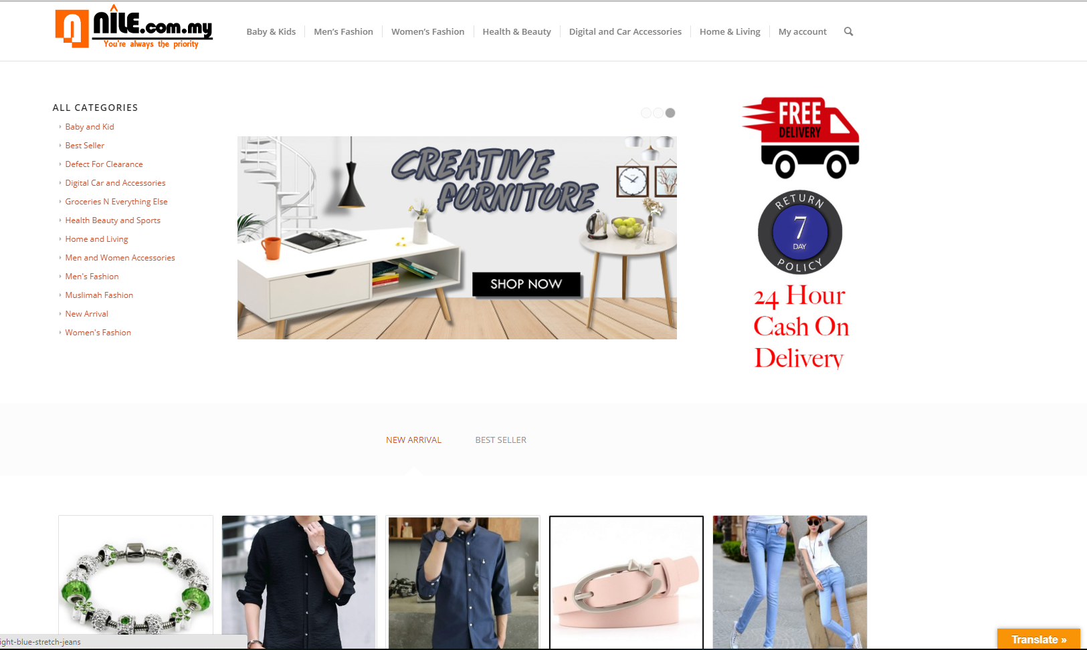

**Figure: Home page**

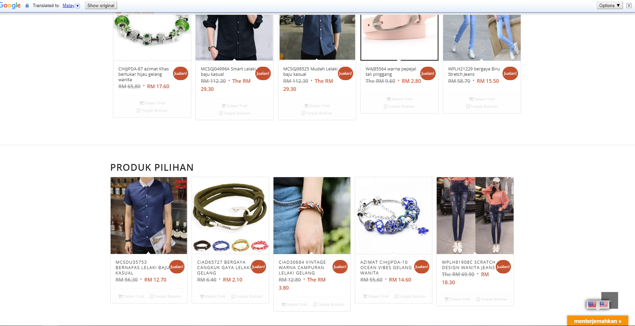

**Figure: Language change**

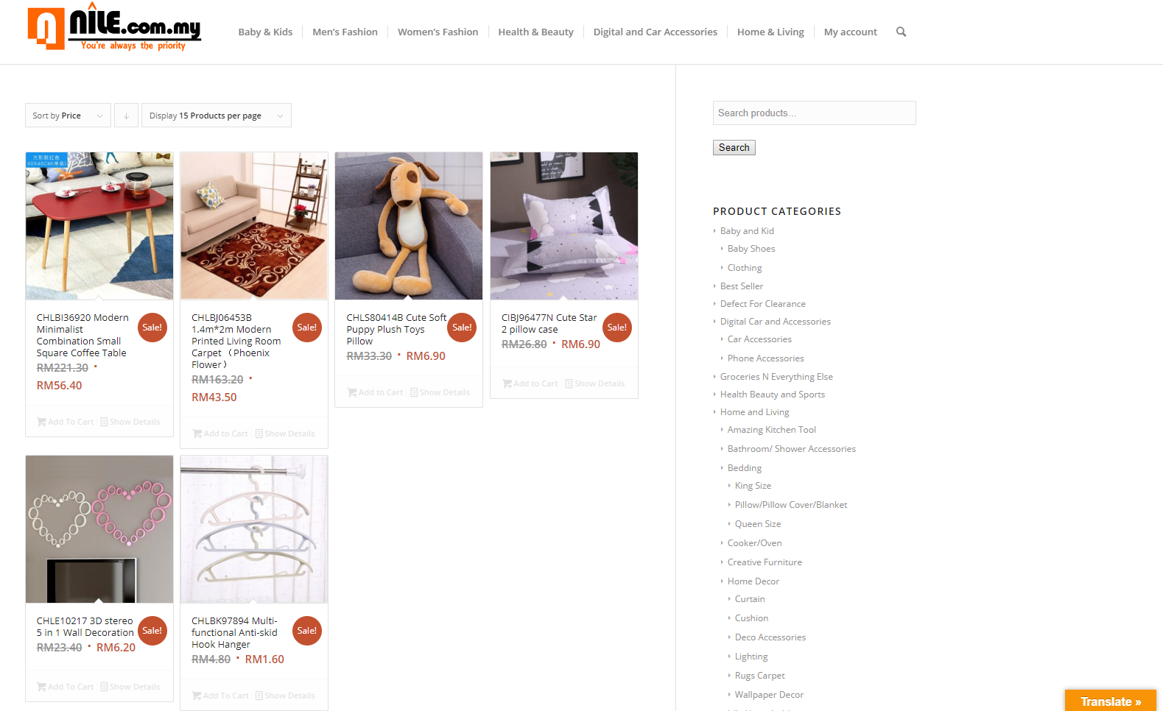

Figure: categories

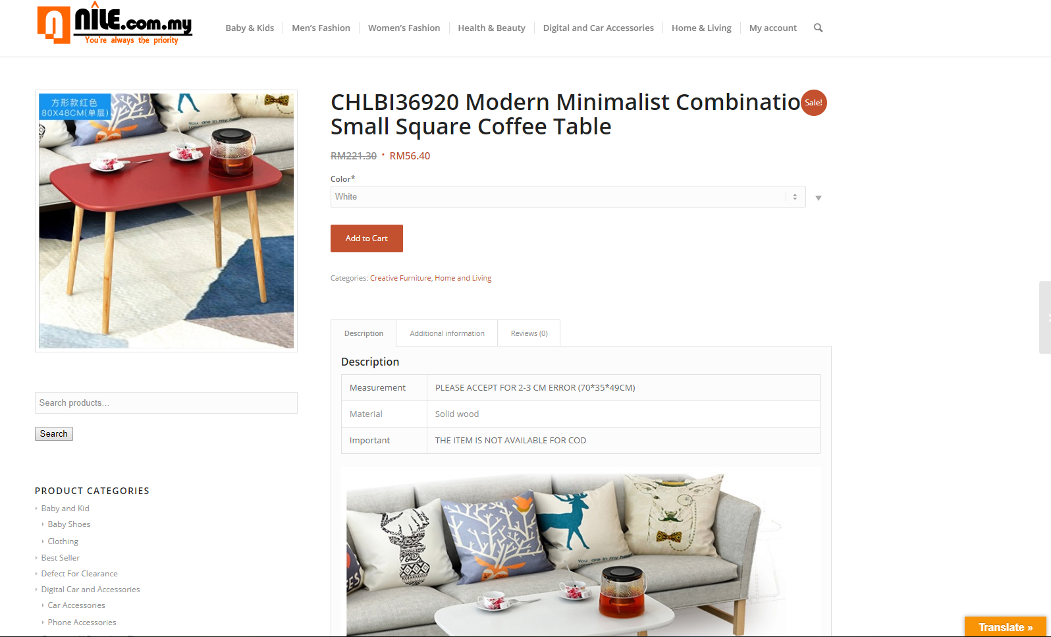

Figure: Description of products

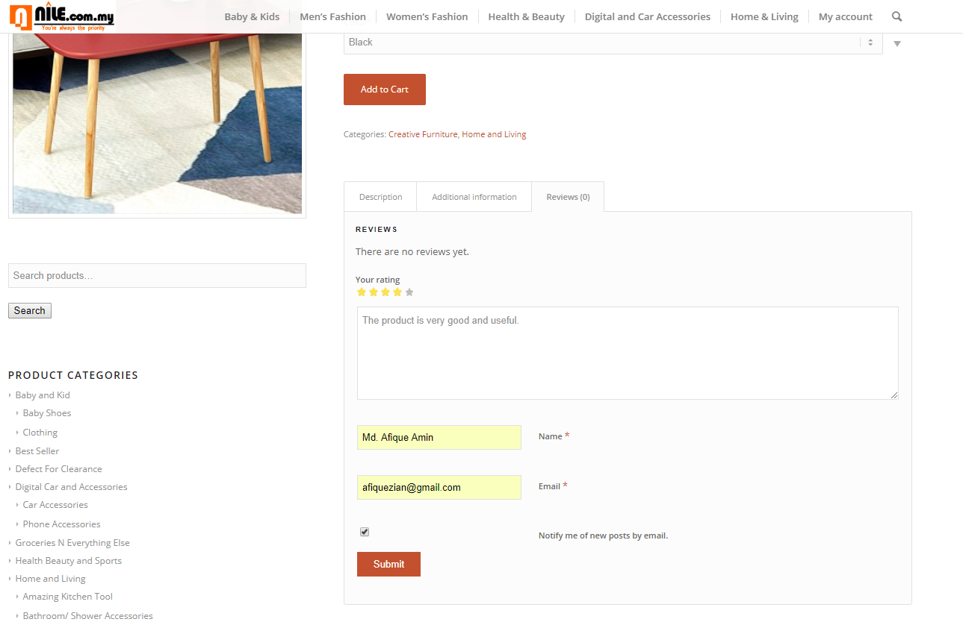

Figure: Ratings and Comments

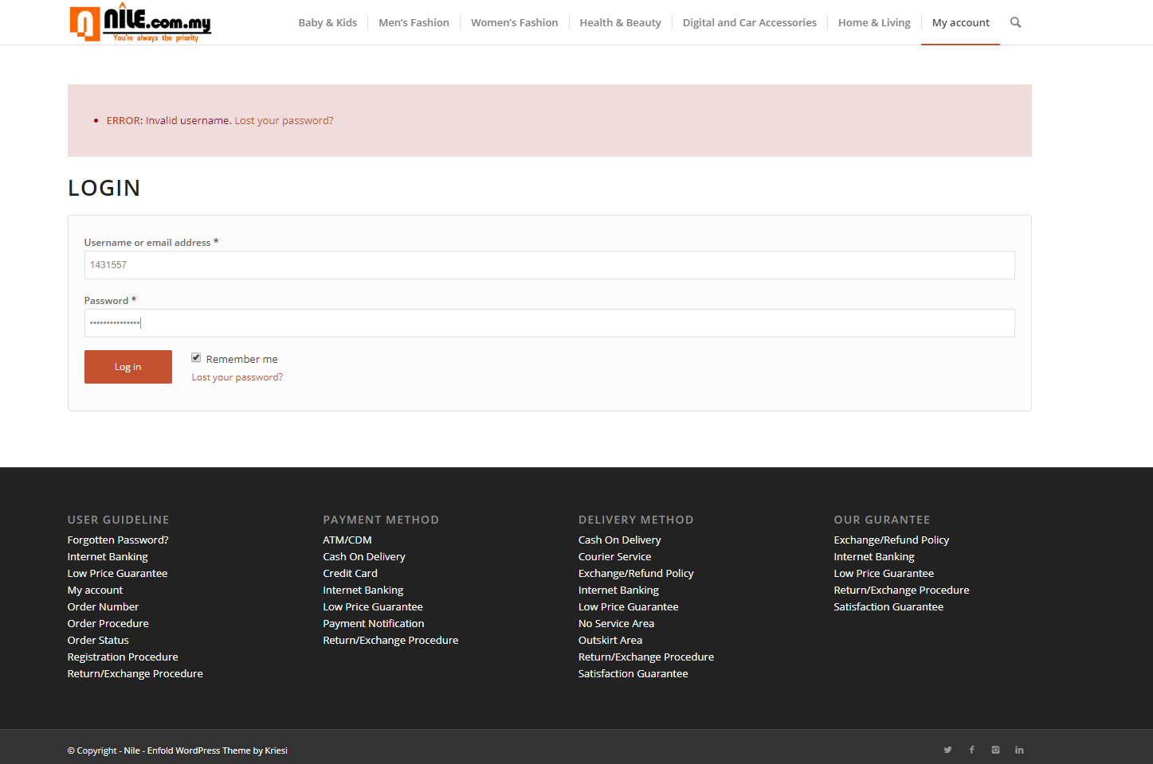

Figure: logIn with wrong password

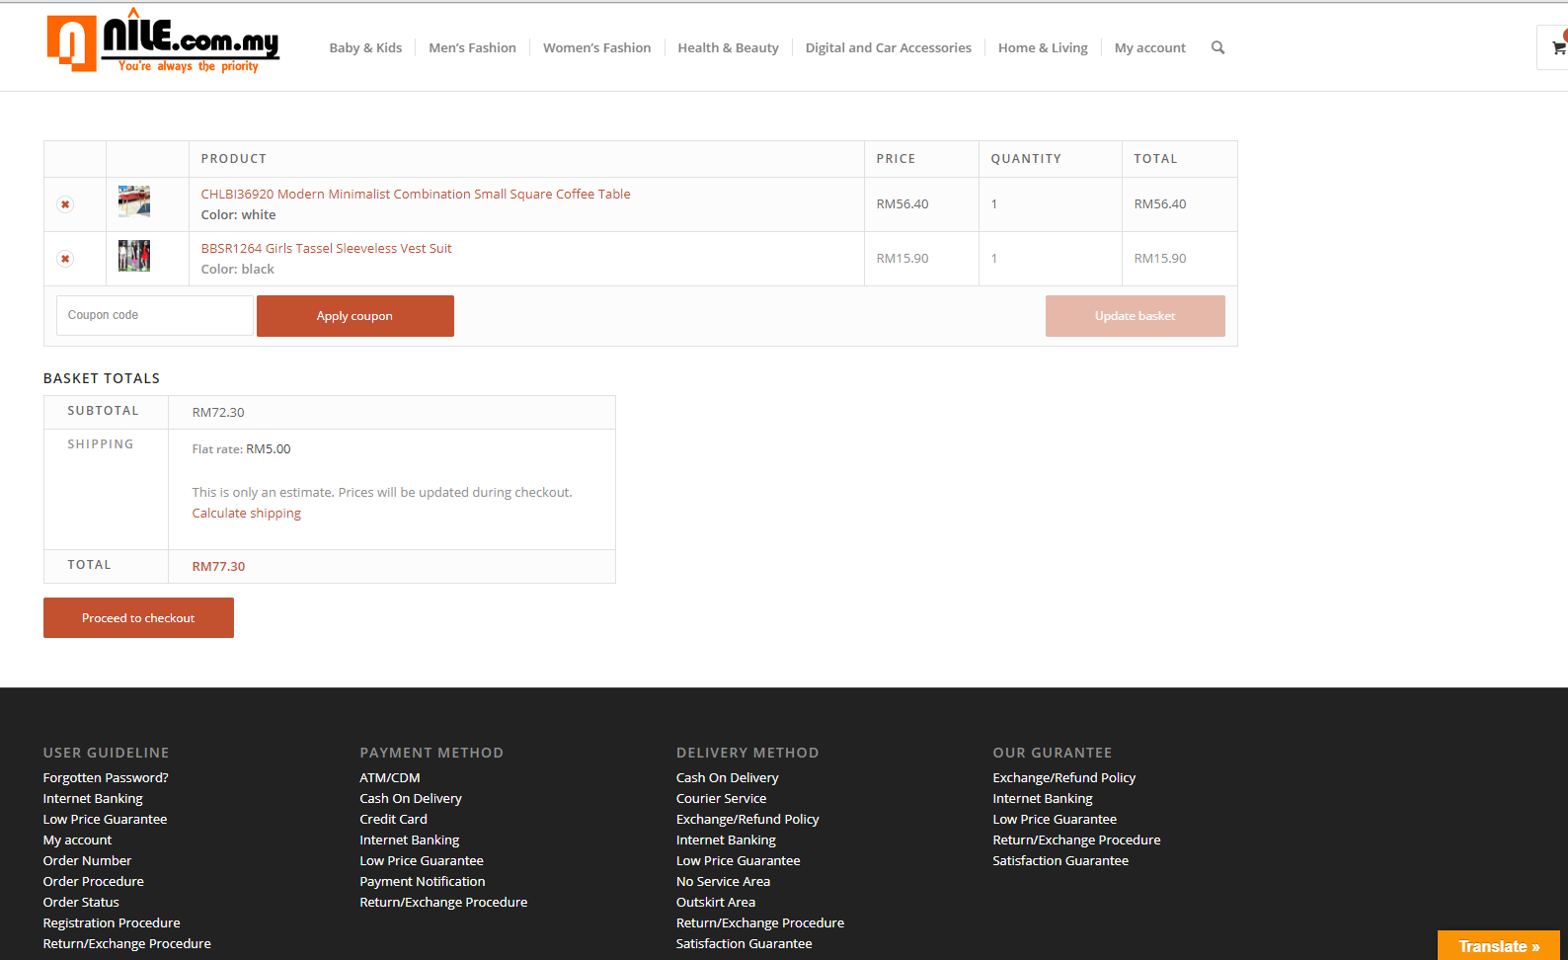

Figure: Add to Cart

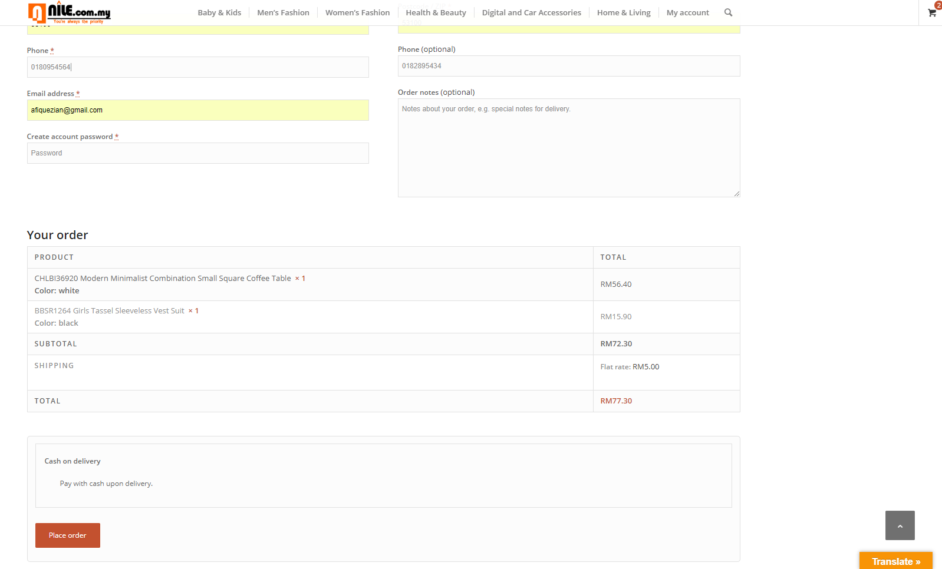

Figure: Billing address and order

**Attachments A:**

**PART A: Usability Questionnaire**

Based on the given scale, please tick [√] the box that best reflect your agreement towards each statement:

| **Statement** | **Strongly Disagree**  **1** | **Disagree**  **2** | **Neutral**  **3** | **Agree**  **4** | **Strongly Agree**  **5** |
| --- | --- | --- | --- | --- | --- |
| I thought Nile.com was easy to use |  |  |  |  |  |
| I would use application frequently |  |  |  |  |  |
| I found it difficult to keep track of where I were in application |  |  |  |  |  |
| I thought most people would learn to use this application quickly |  |  |  |  |  |
| I can get information quickly |  |  |  |  |  |
| Application’s content makes me want to explore more |  |  |  |  |  |
| Application’s content would keep me coming back |  |  |  |  |  |
| Application is well organized |  |  |  |  |  |

**PART B: Subjective Questionnaire**

1. What do you LIKE most about the application?
2. What do you DISLIKE most about the application?
3. Do you have any recommendations on how this application could be improved?

**- Your cooperation is very much appreciated. Thank you! :) -**

**References:**

1. <http://www.nile.com.my/index.php>
2. <https://inclusivedesignprinciples.org/>
3. <https://www.interaction-design.org/literature/article/bad-design-vs-good-design-5-examples-we-can-learn-frombad-design-vs-good-design-5-examples-we-can-learn-from-130706>
4. Benyon, D. (2013). Designing Interactive Systems: A Comprehensive Guide to HCI and Interaction Design, Addison-Wesley.
5. Dix, A., Finlay, J., Abowd, G. & Beale, R. (2004). Human computer interaction, (3rd ed.), USA: Pearson-Prentice Hall.
6. <https://www.interaction-design.org/literature/article/bad-design-vs-good-design-5-examples-we-can-learn-frombad-design-vs-good-design-5-examples-we-can-learn-from-130706>
7. <http://nile.cloudaccess.host/car-accessories>
8. <https://en.wikipedia.org/wiki/Usability_testing>

**Youtube link:**

You will find the whole compiled video of our website usability testing here

[**https://www.youtube.com/watch?v=__I22k9mNaQ&t=2357s**](https://www.youtube.com/watch?v=__I22k9mNaQ&t=2357s)

**Link Of The Website:**

**http://nile.cloudaccess.host/car-accessories**

…………….END……………